**Simplilearn-_Phase_-2_-project-_FSJD-_** **FlyAway**

**Project Detail**

Project Name: FlyAway

**Project Version: 1.0**

**GitHub repository link:**

https://github.com/ankitsinghpawar2022/Simplilearn-_Phase_-2_-project-_FSJD-_-FlyAway

**Developer Detail**

Name: Ankit Singh Pawar

Simplilearn user ID: [ankitsinghpawar@gmail.com](mailto:ankitsinghpawar@gmail.com)

* ***Project Specification :***

This Project contains a website portal of online flight booking company FlyAway . This website contains sign up page for new customers , a login page for old customers who had already signed up and also admin login is a platform where website admin (only one) able to access change the password .A search form in the homepage to allow entry of travel details, like the date of travel, source, destination, and the number of persons. Based on the travel details entered, it will show the available flights with their ticket prices. Once a person selects a flight to book, they will be taken to a register page where they must fill in their personal details. In the next page, they are shown the flight details of the flight that they are booking, and the payment is done via a dummy payment gateway. On completion of the payment, they are shown a confirmation page with the details of the booking.

In this project I have provided option to go forward and go backword for user compatibility .

* ***Task achieved in this project :***

1. Created the flow of the project.
2. Created Git repository .
3. Actual development of the project .
4. Testing of the project with various inputs and search of any error.
5. Pushed the project into my GitHub repository .
6. Created the specification document which posses all information regarding the project itself.
7. Created output Screenshot document and source code document.

* ***Flowchart*** :

1. Welcome page to the user.
   * 1. Registration page link
     2. Login page link
     3. Admin login page
2. After signing up and logging in we provided an option to access our website.
3. After accessing we have provided product related options like access all products access products by sorting name, colour, category and price with order option.
4. In admin login platform we have provided four main options viz.
   * + - 1. Change password
         2. Access Flight booking related options
         3. Access user related options
         4. Access booking reports.
5. In every stage I’ll had provided sorting options for ease.
6. Option to return to the main menu.

* ***Java concepts used in project :***

1. Eclipse IDE
2. MySQL Relation Database Management System
3. Apache Tom-Cat 10 server
4. Java Servlets
5. Java Server Pages (JSP)
6. HTML
7. Apache Maven

JDBC Java Database Connectivity

**Technologies and tools Used:**

* Servlet: to do the business logic and works a controller for the project.
* JSP: to handle the presentation view.
* SQL: to create and manage the database.
* JDBC/Hibernate : to make operations on the database for the project.
* CSS: to format the contents.
* Eclipse: to write and run the code.
* Tomcat: to run and deploy servlet application.

**Sprint Plan:**

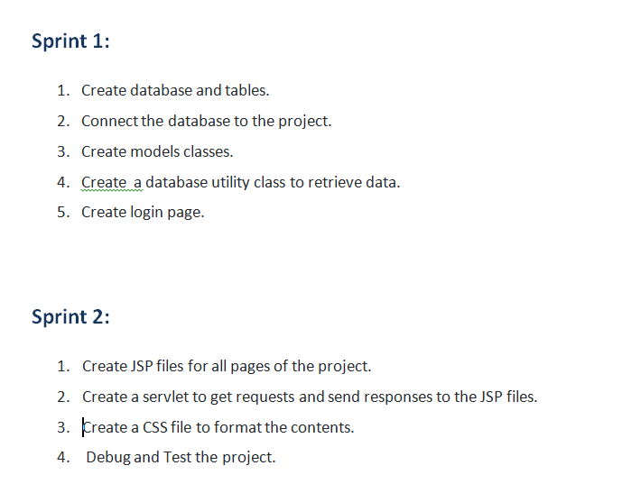

**Concept used in this programme:**

1. Object-Oriented: used to create and model objects for users and their credentials.
2. Databases: used to store and retrieve data.
3. Data Sources: used to define a set of properties required to identify and access the database.
4. Collections: used some collections such arraylist to store collection of data.
5. Exception Handling: used to catch problems that arises in the code especially in I/O blocks.
6. Cookies: to store log-in data on the client browser. Searching and Sorting

**How to run the program:**

1. clone project
2. Import\create mysql database “flyaway” file to your database administration tool.
3. Go to “\src\main\webapp\index.jsp.
4. Edit the database’ properties such as username, password and driverClassName to be suit to your database administration tool.
5. Now run program on a server.
6. To login you must enter admin for both username and password.